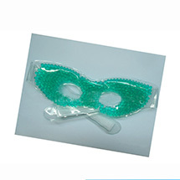

Bead Pearl Gel Eye Masks Assorted Colors
certificate:SGS/MSDS
function:Relax and revitalize tired, puffy eyes with this facial refresher.
material:pvc
the internal:gel bead
name:cooling gel eye mask
printing:customized
color:customized
size:70*10cm
Company: Shanghai Bing Fan Industrial Co., Ltd.
Bead Pearl Gel Eye Masks Assorted colors
Relax and revitalize tired, puffy eyes with this facial refresher. Quick, easy and effective-soothes strained or irritated eyes

